Central Ohio Police Motorcycle Challenge
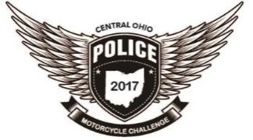Supporting NC4K 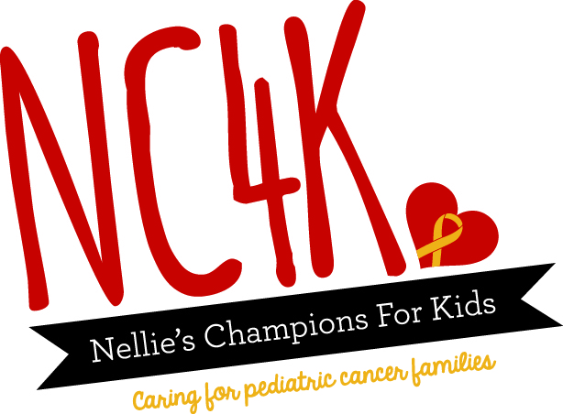

Resources Close to the Ohio Fire Academy and Hotels
The Reynoldsburg Division of Police
7240 East Main Street Reynoldsburg, Ohio 43068 614.866.6622
RPD Motor Unit
Sgt. Mark Moser mmoser@reypd.com 614.937.7358
Officer James Triplett jtriplett@reypd.com 614.322.6939
Ohio State Fire Academy
8895 East Main Street Reynoldsburg, Ohio 43068 614.752.7196
Nellie’s Champions for Kids - NC4K
6096 East Main Street Columbus, Ohio 43213 614.300.3995
http://www.nc4k.org/
AMA Motorcycle Hall of Fame Museum
13515 Yarmouth Drive Pickerington, Ohio 43147 614.856.2222
Centennial Park Harley Davidson
12477 East Broad Street Pataskala, Ohio 43062 740.964.1121
Iron Pony Motorsports
5346 Westerville Road Westerville, Ohio 43081 614.901.7661
Easton Town Center
160 Easton Town Center Columbus, Ohio 614.337.2200
Central Ohio Police Motorcycle Challenge
Supporting NC4K

Resources Close Hotels
Blacklick Woods Golf Course
7309 East Livingston Ave Reynoldsburg, Ohio 43068 614.861.3193
Blacklick Woods Metro Park
6975 East Livingston Ave Reynoldsburg, Ohio 43068
Blacklick Woods features 643 acres of woods, fields, seasonal swamp ponds, a small prairie and a golf course. It has one of the best remaining beech-maple forests in Central Ohio along with a buttonbush swamp. The forest areas are laced with trails that wind through a swamp forest with oak and white ash along with red maple, elm, shagbark, bitternut hickory and dogwood.
Taylor Square
- Walmart
- Target
- Gander Mountain
- Best Buy
- Sam’s Club
- BW3’s
- Olive Garden
- TGI Fridays
- Panera Bread
- O’ Charley’s
- Five Guys
- Chipotle
- Logan’s Roadhouse

