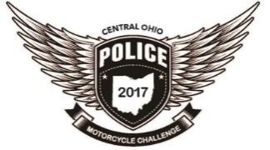Supporting NC4K
Schedule of Events
Monday - August 21st -Tuesday August 22nd
7am – 3pm - Practice Basic Motor Officer Cone Patterns
Wednesday August 23rd
7am-2pm - Practice A / B Courses / Slow Ride / Team Ride
2pm-3pm - Walk thru (non-mandatory) of timed events
Thursday August 24th
7am – 10am – Practice A/B Courses / Slow Ride / Team Ride
10am – 11am - Mandatory Registration/Participant Meeting – walk thru timed courses
12pm-3pm – The Eliminator Challenge
Friday August 25th
8am-9am - Officer Sean Johnson Memorial Challenge Rider Meeting / Walk Thru
9am – 11am- Officer Sean Johnson Memorial Challenge
12pm- Officer Sean Johnson Memorial Challenge Award Presentation
1pm – 4pm - Timed Runs Course A Odd / B Even and Slow Ride Official Time Final
Saturday August 26th
8am-10am Opening Ceremony
11am-1pm - Timed Runs Course A Even / B Odd
1pm-3pm – Partner Ride
3pm - Award Presentation

