 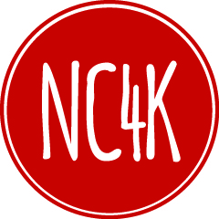

**WAIVER OF LIABILITY – EQUIPMENT DAMAGE**

I, __________________________________________ (insert name), the duly authorized contracting authority for ___________________________________________ (insert name of political subdivision or county/state agency), hereby grant permission and authority for Police Officer ________________________________________ (insert participant’s name), to participate in the 2017 Central Ohio Police Motorcycle Challenge, to be conducted August ___ - ___, 2017 in conjunction with and sponsored and supported by the City of Reynoldsburg, Ohio, the Reynoldsburg Division of Police, the Ohio State Fire Academy, and the charitable organization NC4K.

I understand that this type of training and competition is done with the possibility of equipment damage and/or personal injury to the participants, up to and including the possibility of death. I hereby acknowledge and understand that Police Officer _______________________________ ________________ (insert participant’s name), will be required to sign a separate Release of Liability/Waiver for any such injuries or claims to protect the City of Reynoldsburg, Ohio, the Reynoldsburg Division of Police, the Ohio State Fire Academy, and the charitable organization NC4K.

On behalf of ______________________________________ (insert name of political subdivision or county/state agency), I hereby assume all risks to our motorcycle or other police equipment attendant to our Officer competing in the Central Ohio Police Motorcycle Challenge. I further release, on behalf of this organization, the City of Reynoldsburg, Ohio (an Ohio municipal corporation), the Reynoldsburg Division of Police (a division of the City of Reynoldsburg), the Ohio State Fire Academy (the training academy of the Ohio Department of Commerce, Division of the State Fire Marshal) , and the charitable organization NC4K, and their agents, employees, and volunteers, from all liabilities, claims, suits, demands, and/or causes of action which may arise from damage to our equipment which may arise from our officer’s participation in this event.

_____________________________ _________________________ ___________

Name Agency/Employer Date